Work In Progress Password Cracking Project

Section 1: Brute Forcing a Password

Brute forcing a password is rarely ever an efficient way to try and get into a user’s device or account. As shown below in the image provided, attempting to get into another user’s device remotely and failing after multiple attempts to kick the attempted cracker out.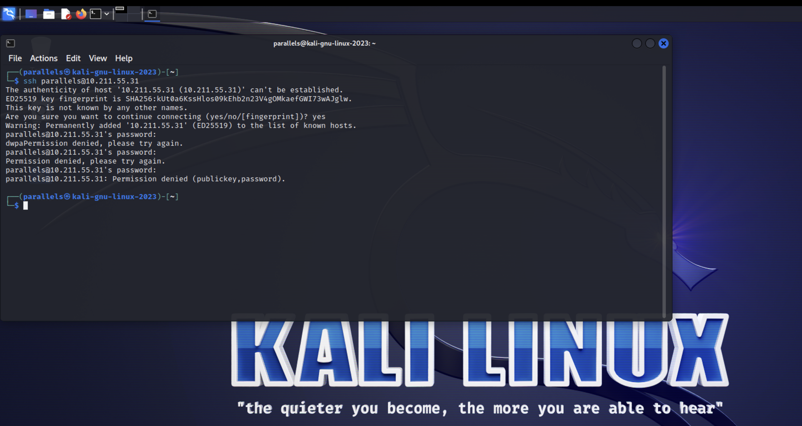

Ideally as a hacker trying to get information from a user’s device, one would think to use automation to try and speed up the process but it may come as a surprise that some password can take potentially years to crack.